FOLDER: DATA/ADMINISTRATIVE SHAPE (Rabigramm)

FILE: Europe_Nuts0_WGS84.shp, Europe_Nuts1_WGS84.shp, Europe_Nuts2_WGS84.shp, Europe_Nuts3_WGS84.shp

* Description: Administrative units in Europe, spatial polygon dataframe.
* Scripts: 2_Exploration_Administrative, 2B_Subset_administrative_DEU_CZ_and_POL
* Output: maps, subset files without Croacia and Sweden (nuts_l0_subset.shp, nuts_l1_subset.shp, nuts_l2_subset.shp, nuts_l3_subset.shp), subset files with Germany, Czech Rep and Poland only (nuts_l0_subset_three, nuts_l1_subset_three, nuts_l2_subset_three, nuts_l3_subset_three)
* 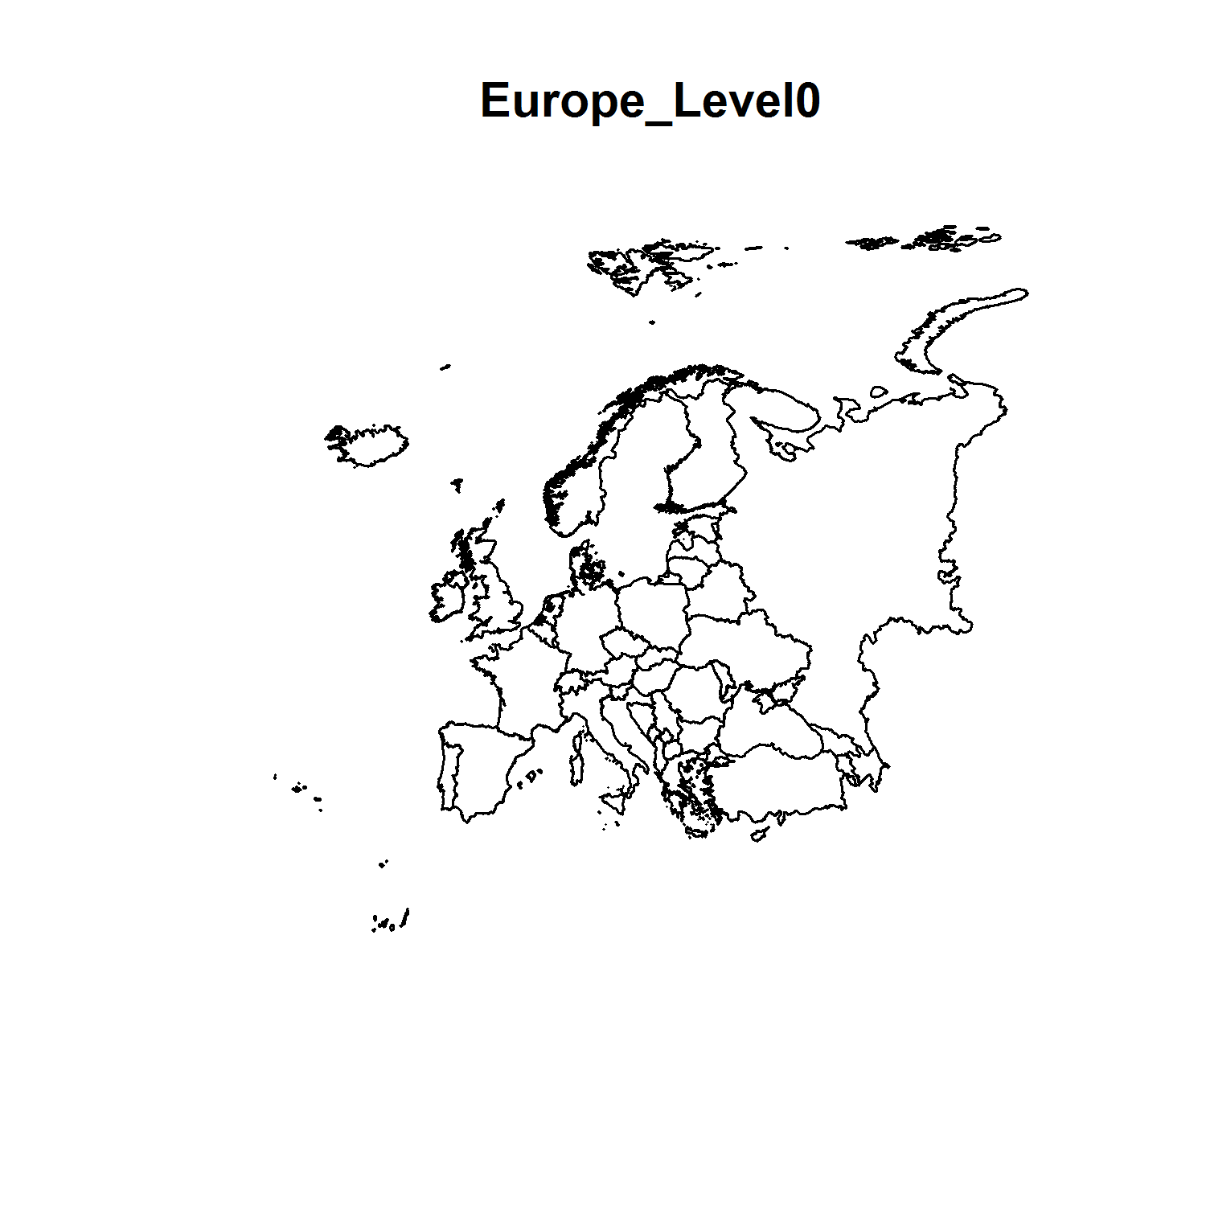 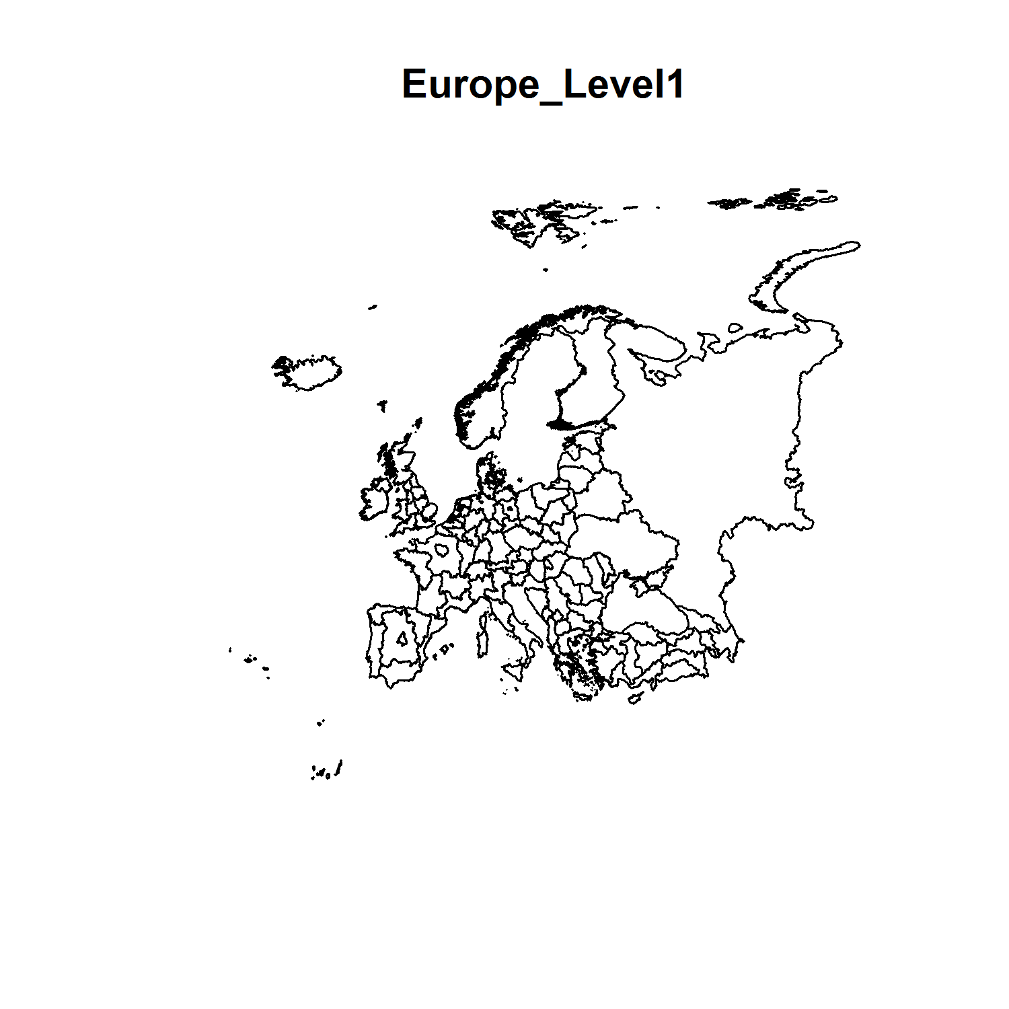 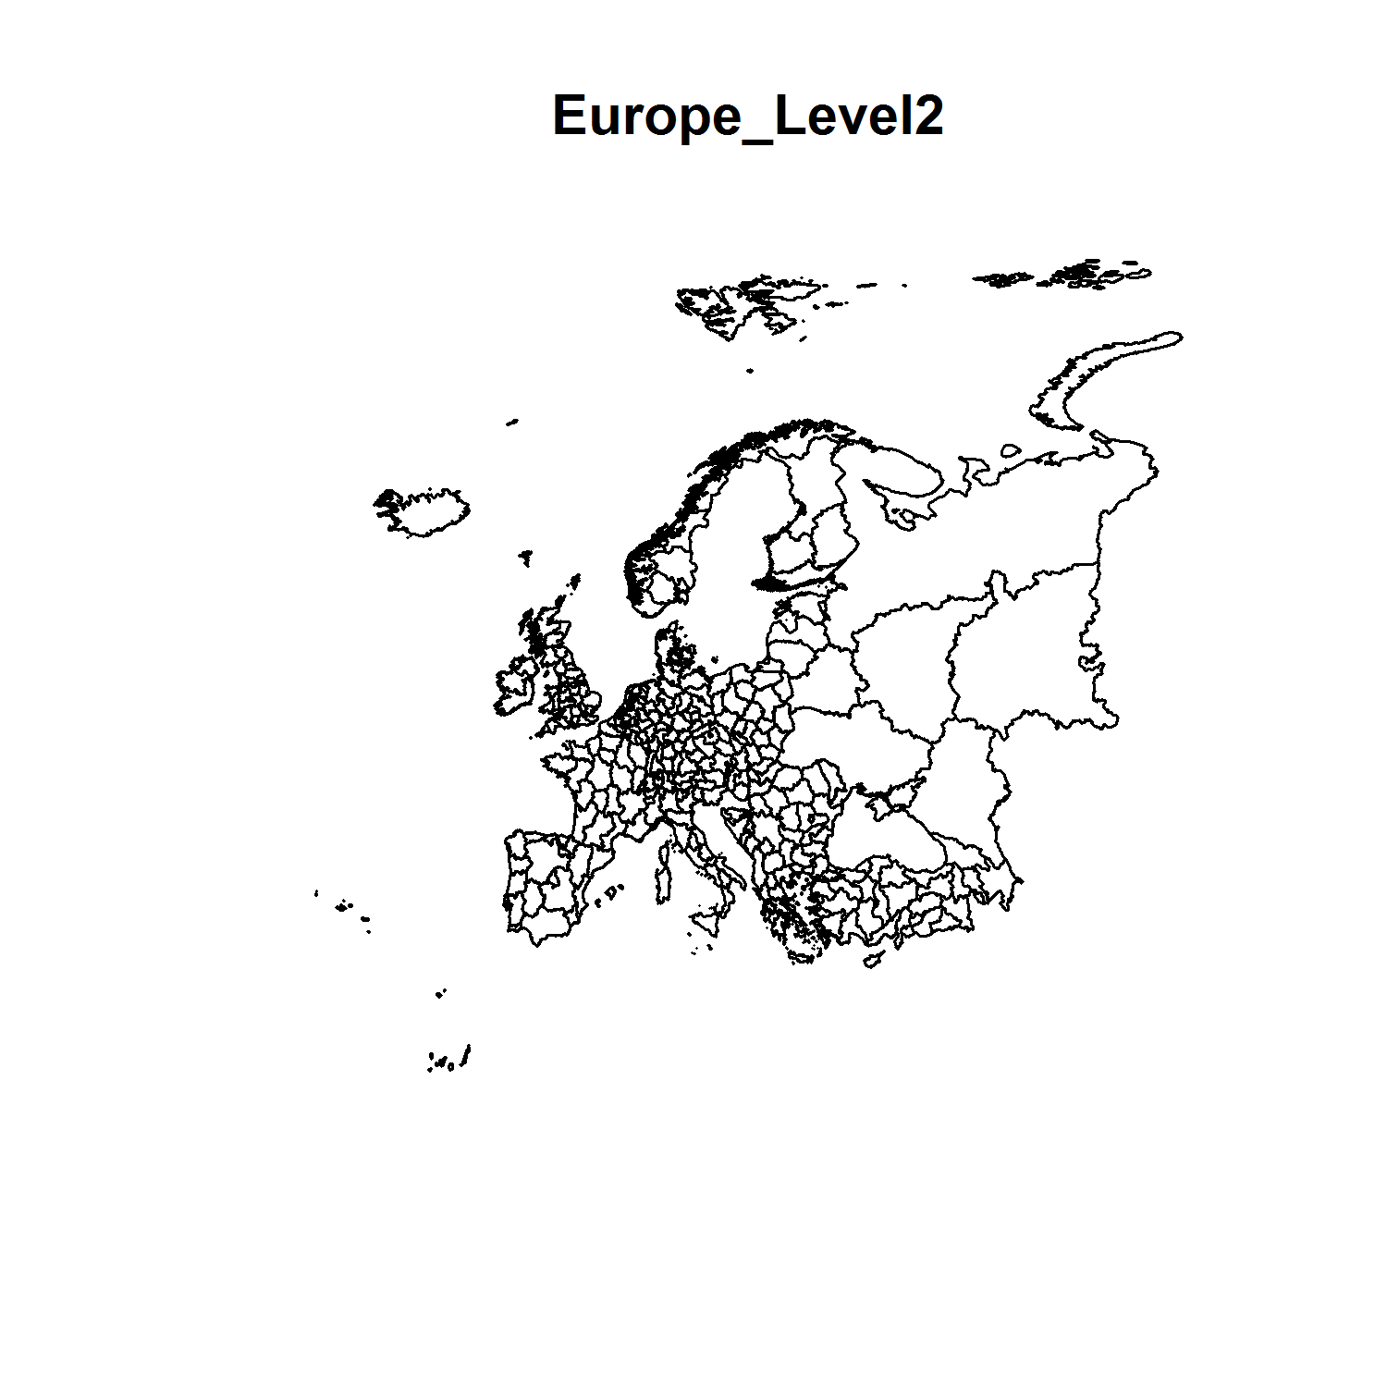 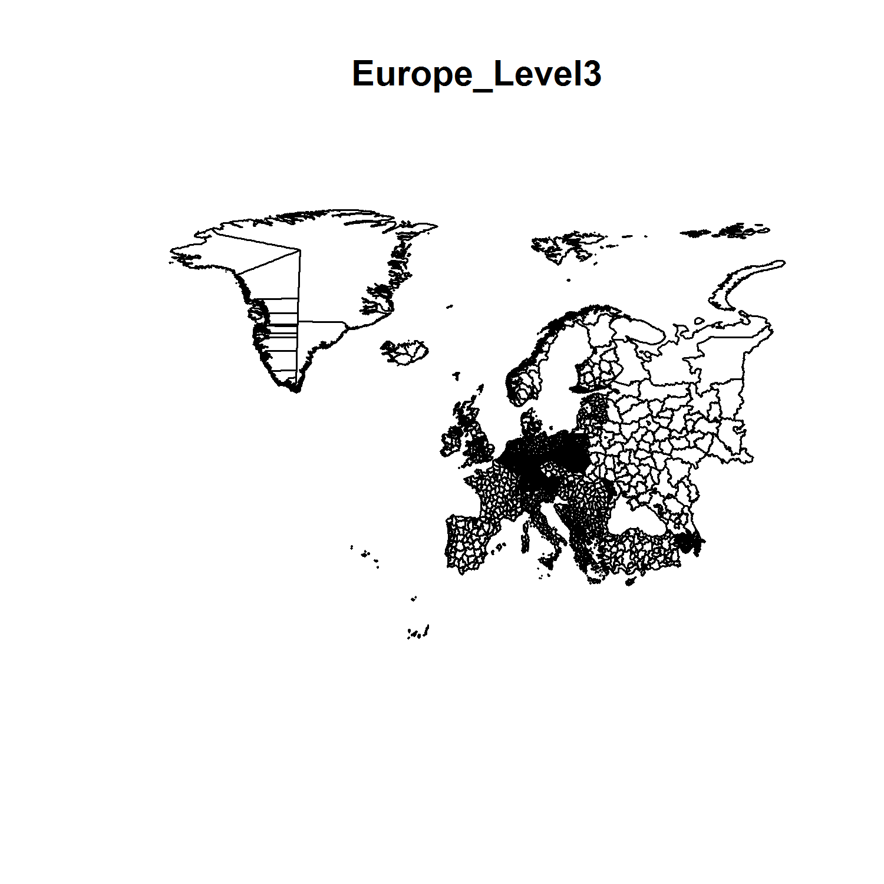

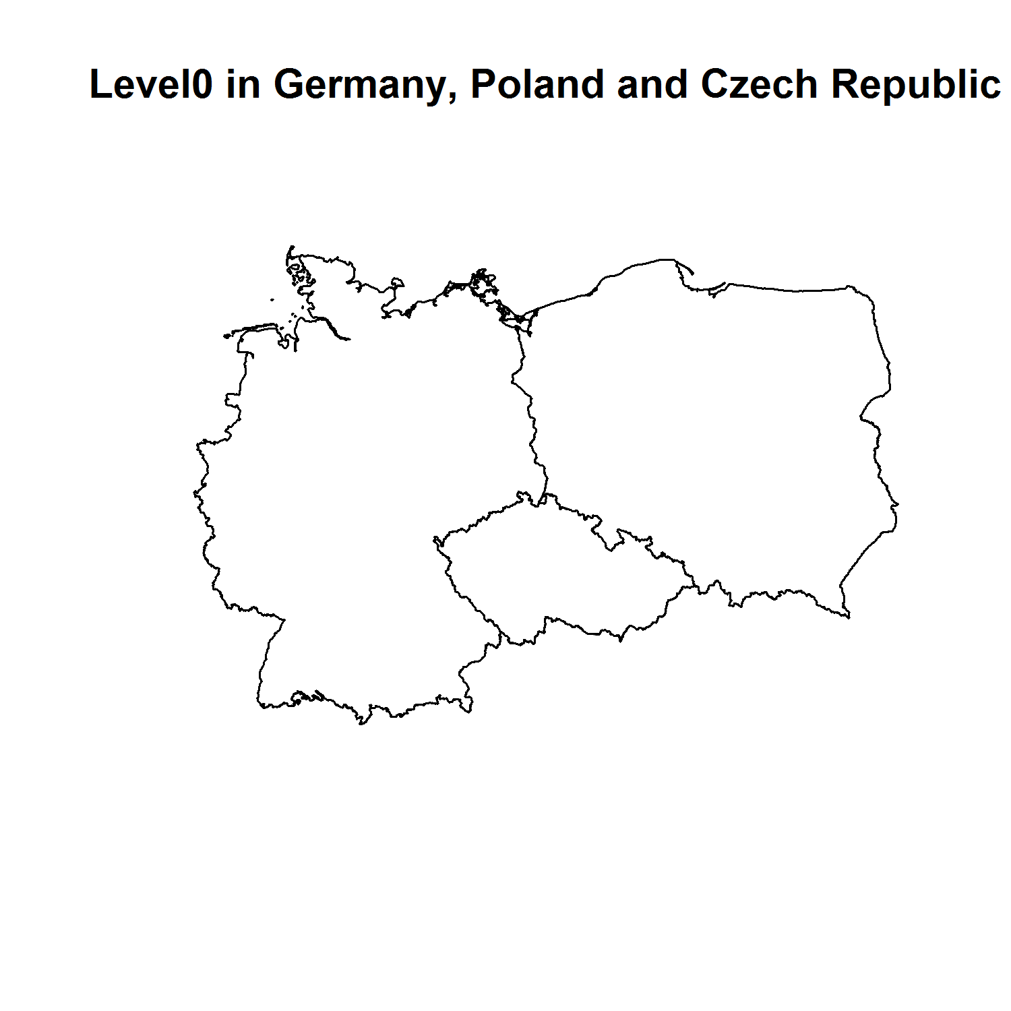 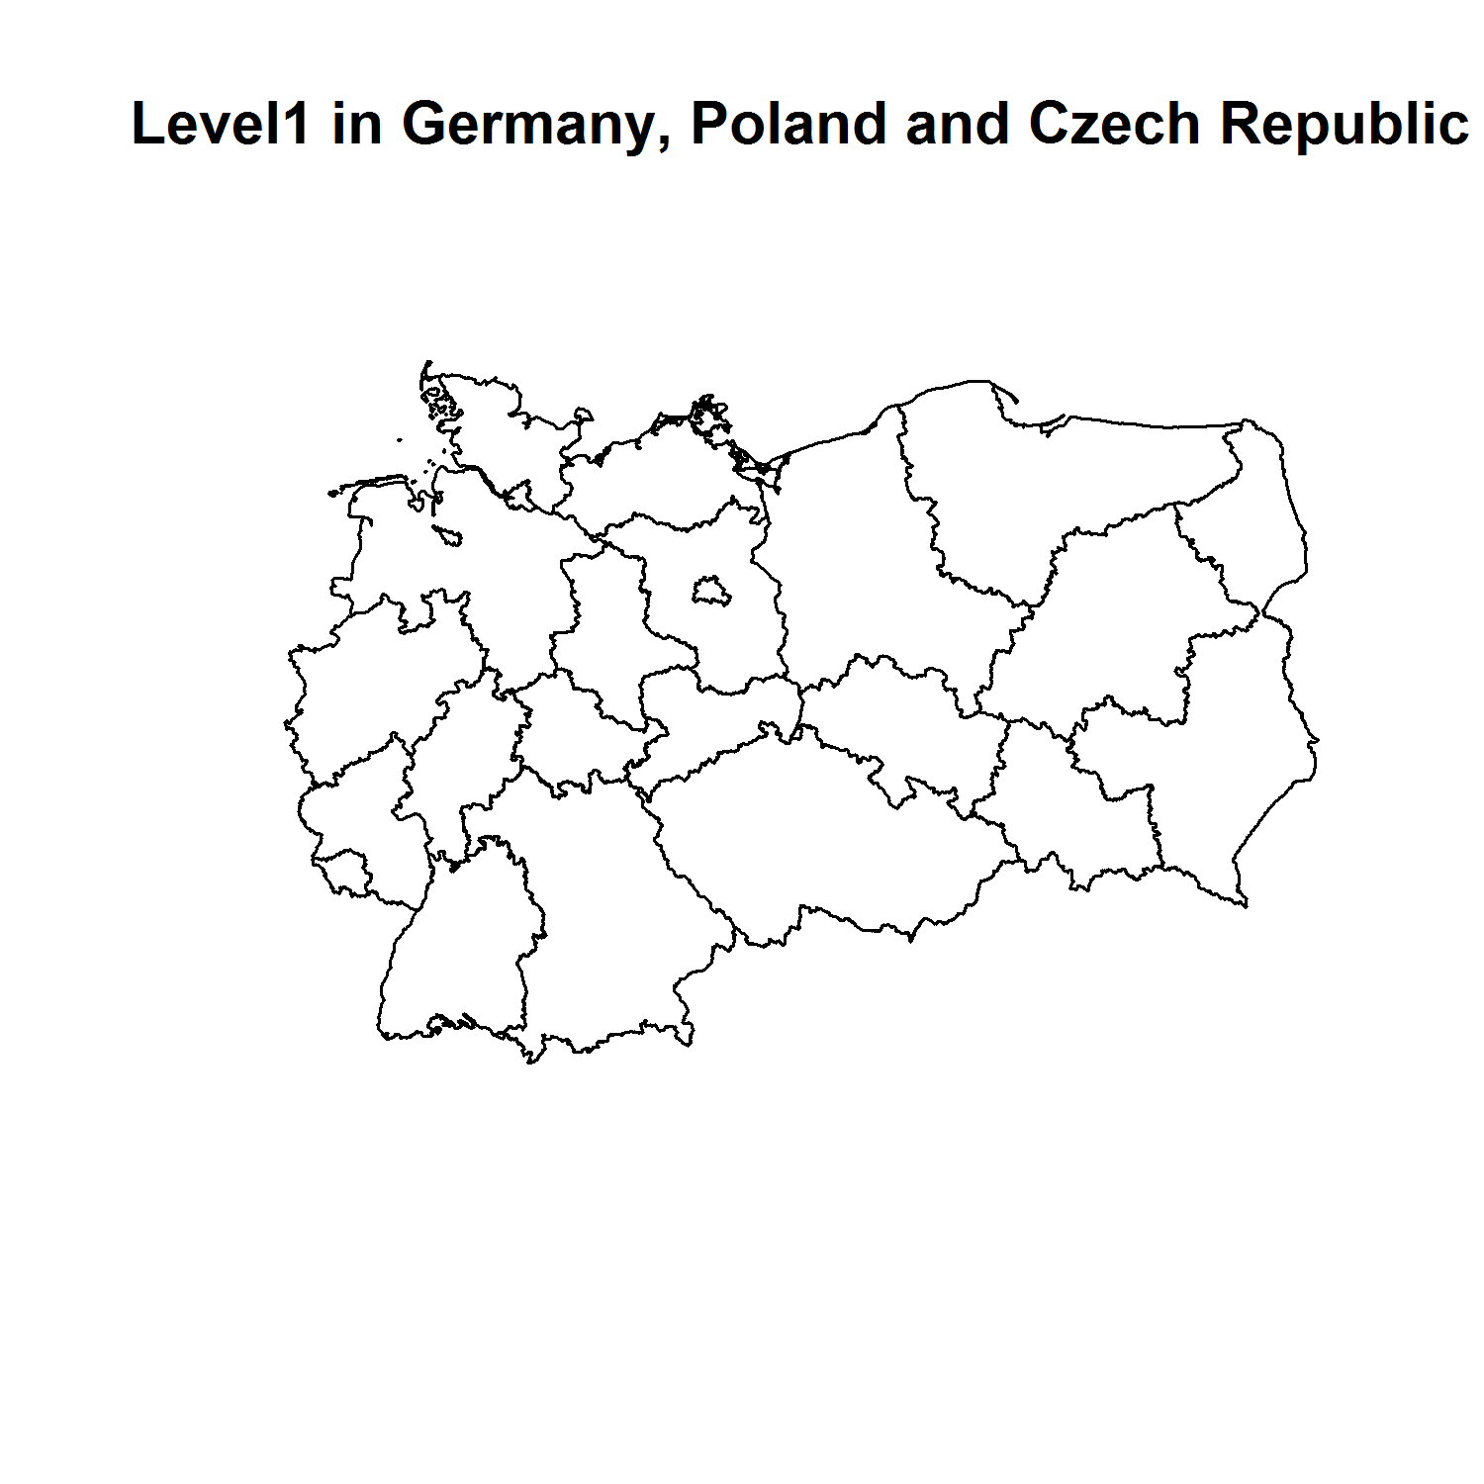 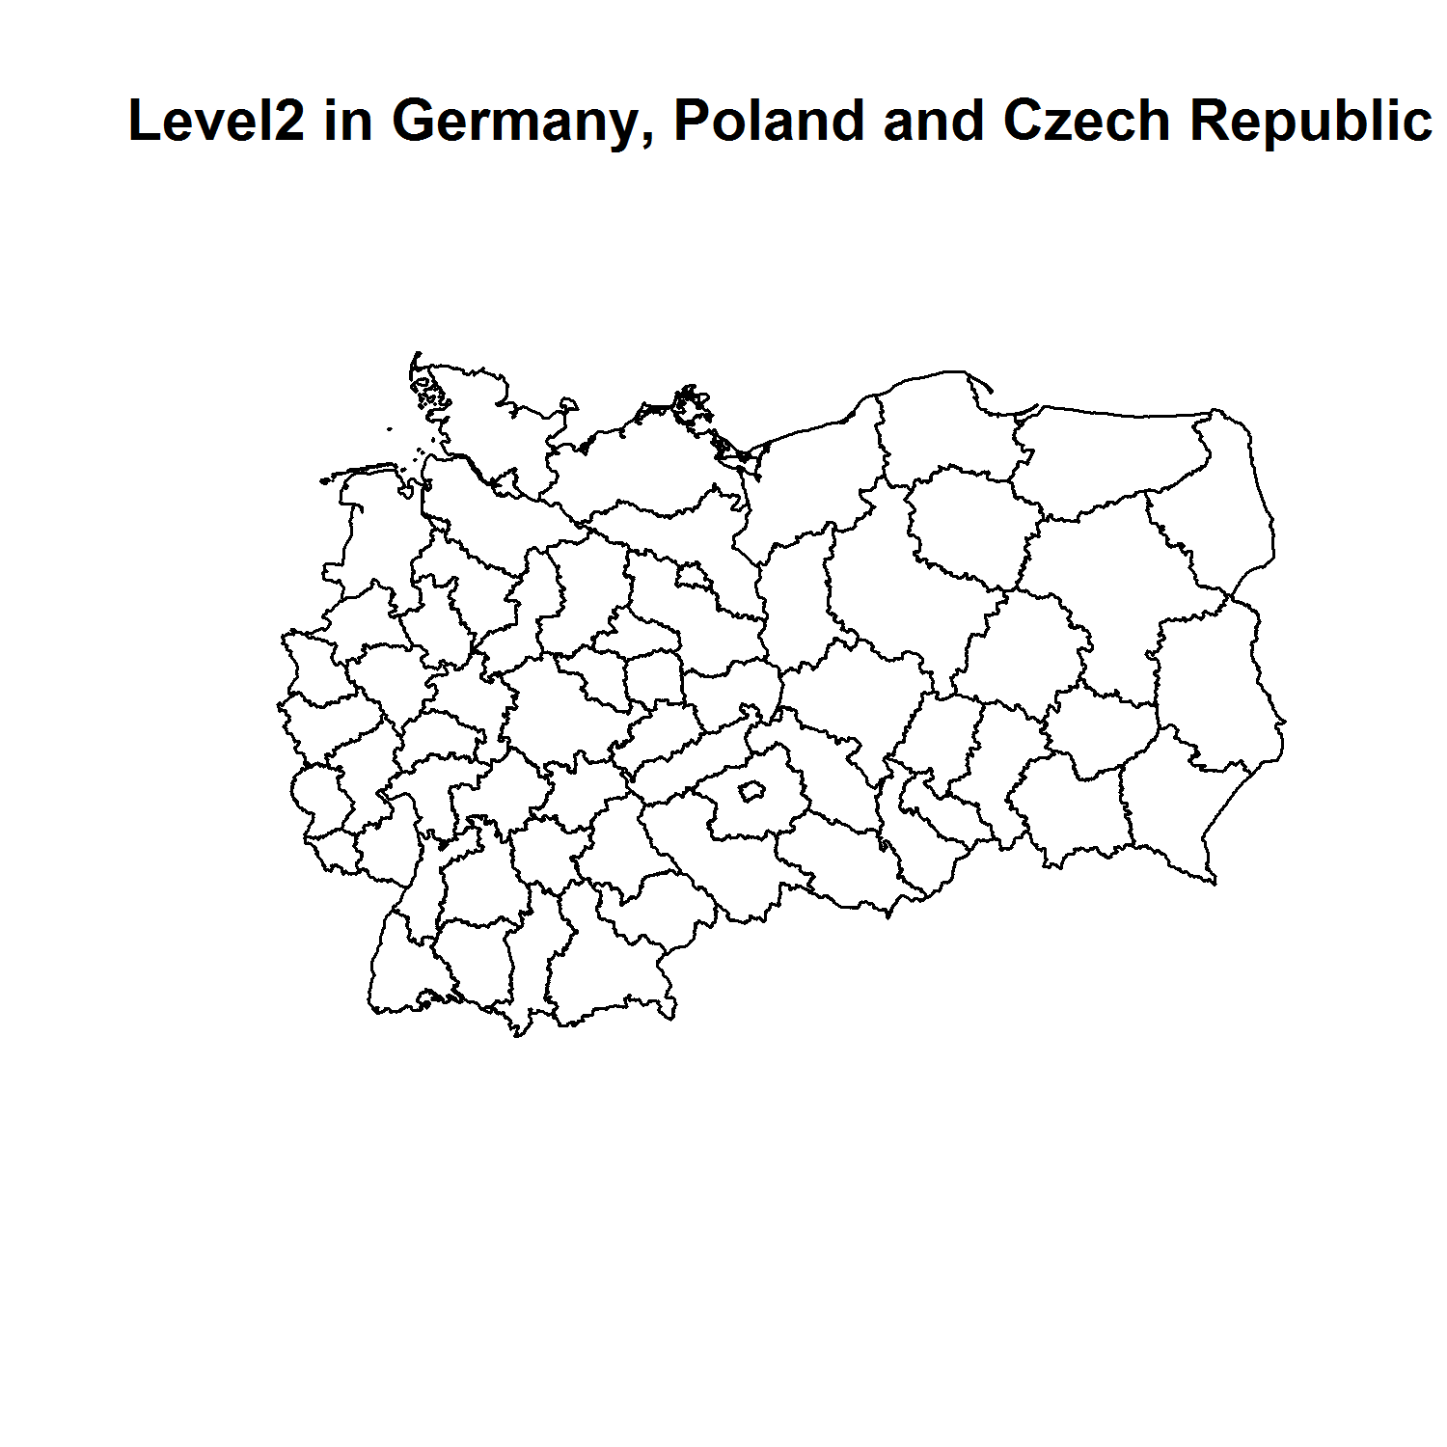

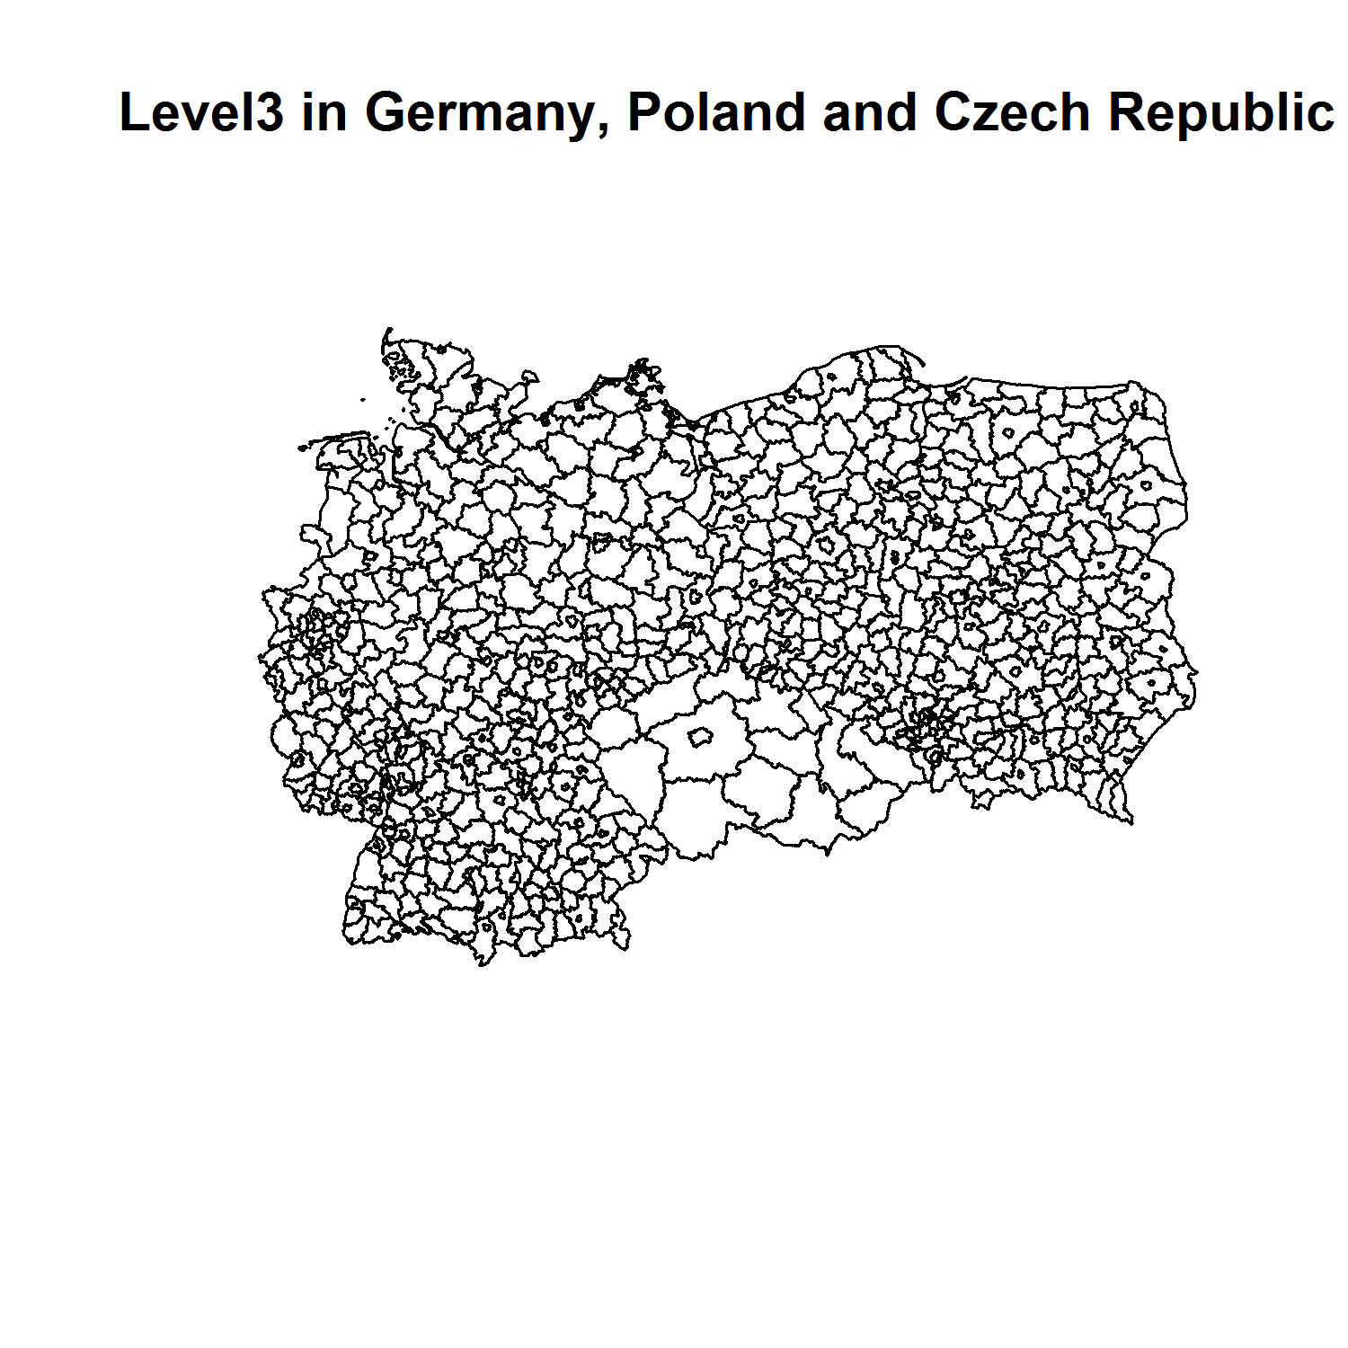

FOLDER: DATA/ADMINISTRATIVE EUROPE

FILE: Europa_level_1, Europa_level_2, Europa_level_3, Europa_level_4, Europa_level_5, spatial polygon dataframe.

Europa_Level_1.shp

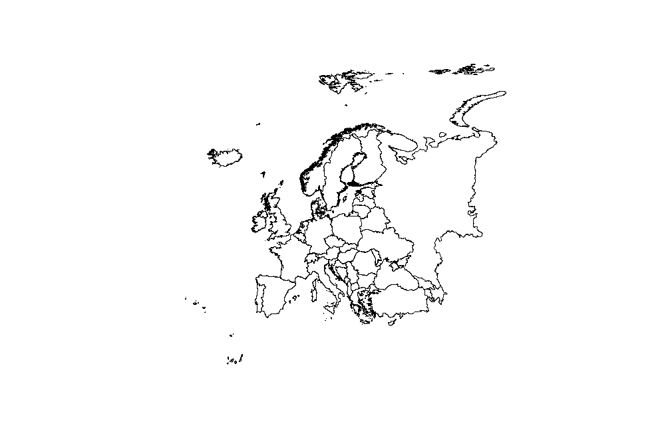

Europa_Level_2.shp

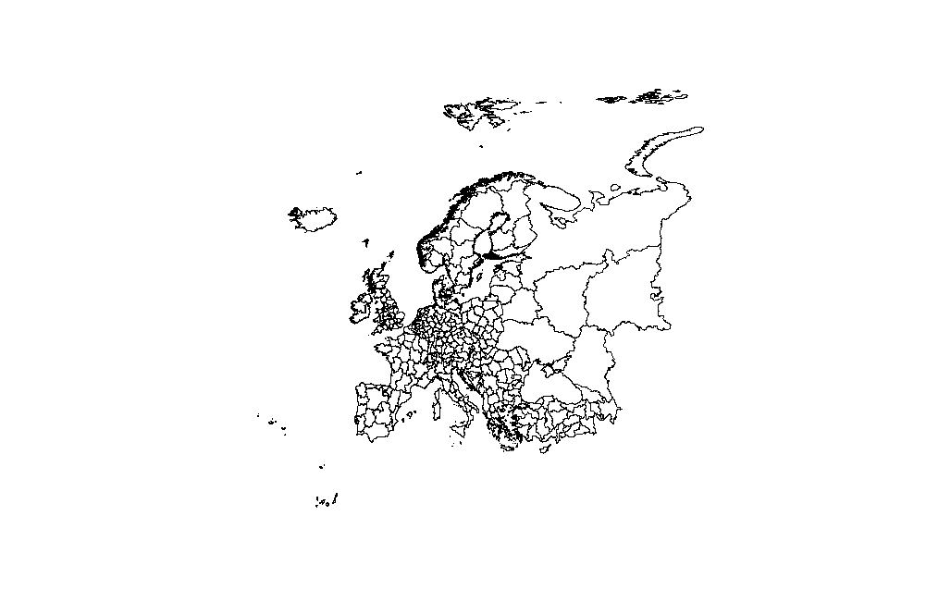

Europa_Level_3.shp

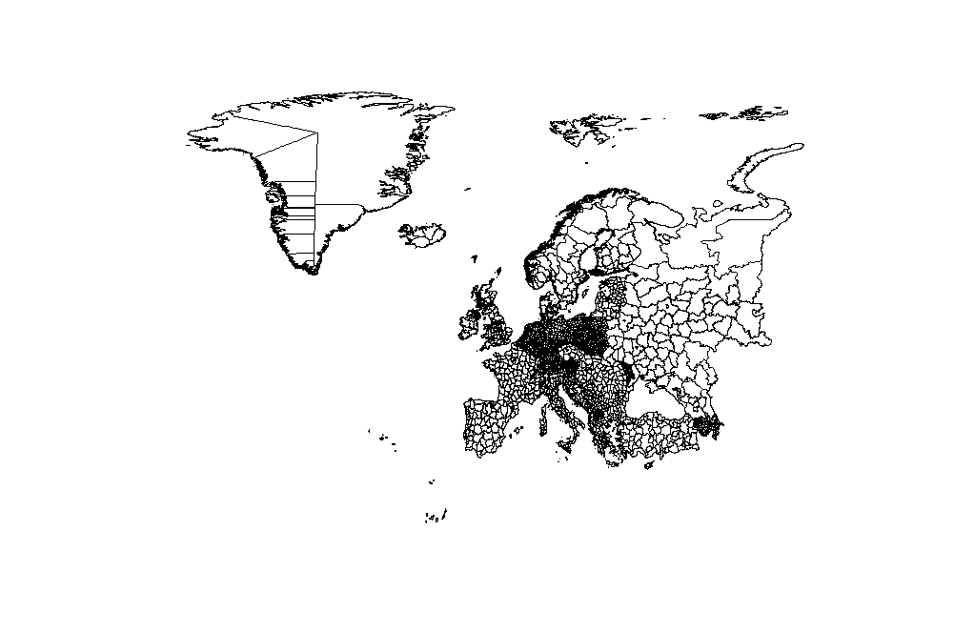

Europa_Level_4.shp

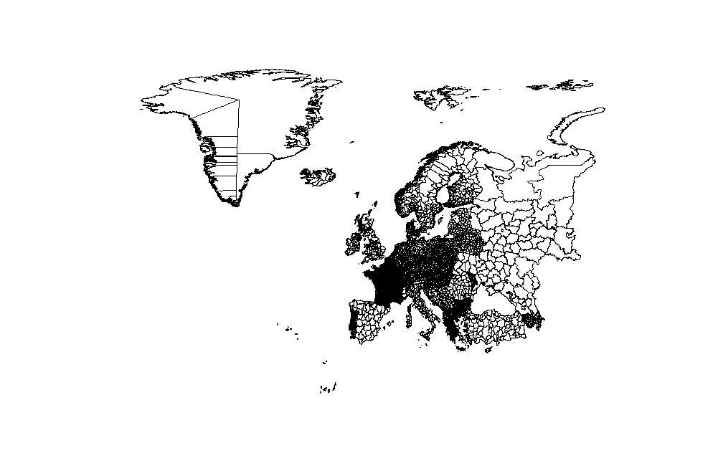

FOLDER: DATA/Administrative region

FILE: Region_aktuell.shp, Region_alle,shp

* Description: Regional boundaries before and after union of some countries, spatial polygon dataframe.
* Scripts: 2_Exploration_Administrative
* Output: maps and subset files with the selected countries only (region_actual.shp)

